Operating systems
Assignment 1 – Ingebrigt Hovind

1 – The process abstraction
- In order to start a program from disk kernel mode is initially needed in order to deliver an interruption to the processor, telling it to finish what it is currently working on and then prioritize starting the new program. There are also several other processes which must happen in order to initialize this new program which demand privileged access. These are, assigning the memory locations, accessing the actual location of the program on the disk and to specify the base and bound of the memory that will be assigned to this program. After the program has been started successfully the processor needs to make the switch to user mode, this is to ensure that the program we just started does not have the privileged access that was just used to start it. Using the principle of least privilege we can ensure a higher level of security.

  - Linux-5.8.3/include/sched.h
  - a) Thread_PID
  - b) acct_vm_mem1

2 – Process memory and segments
- A
- a
- a
  - Static variables remain in memory for the entire duration while the program is running. They are stored in the data segment of the memory

  - var1 is global
  - var2 is local
  - var3 is static (?)

3 - Program code
1)
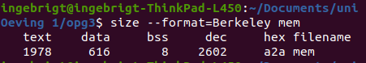
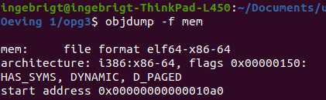
2)

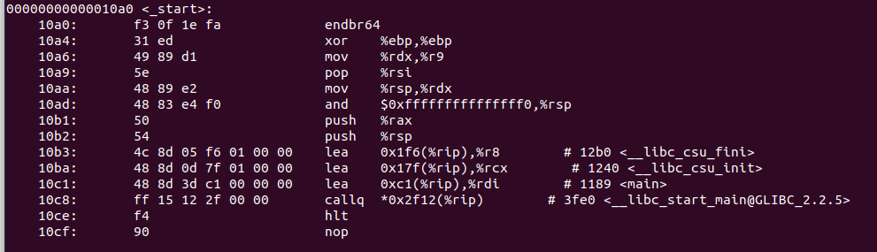
3)

endbr64 is the first function in the start address. This function does …. and is useful because ….

4)
The addresses change between consecutive runs due to Address Space Layout Randomization (ASLR). This is a memory protection mechanism where addresses used by components of a process are randomized so that it is harder for an attacker to exploit specific memory vulnerabilities.

4 – The stack
- Ok
- 8192 kibibytes
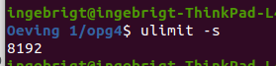
- The commandline alternates in printing “func() frame address” and “func() with localvar”, both including a slightly different address each time. This keeps on happening until “segmentation fault (core dumped)” is printed out and the program stops.
  - The root cause of the error is the infinite recursion in the “func” function. This in addition to creating a new localvar variable every call makes the program overflow its stack with local variables, creating a stack overflow.
- 523444

